江西财经大学
14－15学年第二学期期末考试试卷
试卷代码：12104A 授课课时：64(考试时间110分钟)
课程名称：概率论Probability and Statistics 适用对象：2013级国际学院

1. Fill in the blanks (3 points×5=15 points)
(1)For events A,B,C, 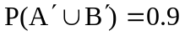,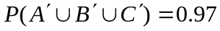, ,then 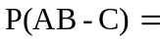 0.07
(2) The area under the standard normal curve between 0 and 1.645 is 0.45
(3) A sample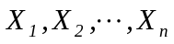drawn from population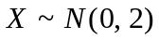. 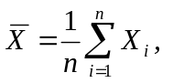
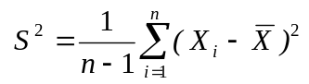, then 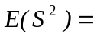 2
(4) If (X,Y) has a pdf 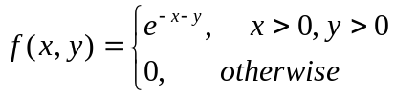 , then 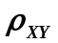(the correlation coefficient)= 0
(5)If 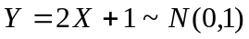, then the distribution of  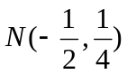
2. There are four choices in each question, but only one is correct. You should choose the correct one into the blank. (3 points×5=15 points)
(1) If X, Y are independent random variables, and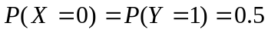,
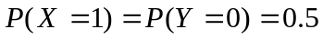, then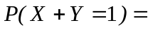( b )
a. 1 b. 0.5 c.0 .25 d. 0

(2) Suppose X, Y are independent random variables, the marginal cdf (cumulative distribution function) of X, Y are 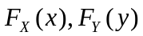,respectively, then the cdf of 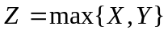 is ( b )
a. 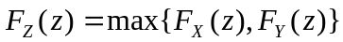. b. 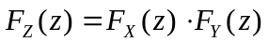
c. 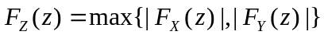. d. none of above
(3) A sample X₁,X₂,…,X_{n} are drawn from the population X~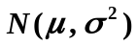, 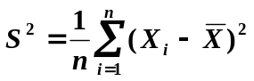, the incorrect statement is ( c )
a. the moment estimator of 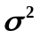is 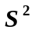 when  is known.
b. the moment estimator of is when is unknown.
c. the maximum likelihood estimator of is when is known.
d. the maximum likelihood estimator of is when is unknown.
(4) If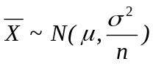, let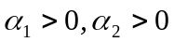, with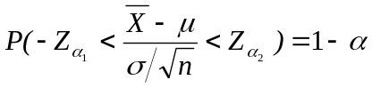, so 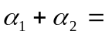( c )
a. 1 b. 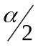 c. d. 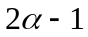

(5) In tests about a normal population mean()，the null hypothesis 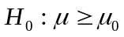, 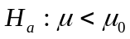. was rejected at significance level =0.01, if selected significance level =0.05，the decision is（ c ）
a. cannot be rejected b. 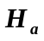 should be rejected
c. should be rejected d. could not conclude a result.

3. (12 points) Suppose that, in a particular city, airport A handles 50% of all airline traffic, and airports B and C handle 30% and 20%, respectively. The detection rates for weapons at the three airports are 0.9,0 .5, and 0.4, respectively. If a passenger at one of the airports is found to be carrying a weapon through the boarding gate, what is the probability that the passenger is using airport A? Airport C?
Solution: P(A)=0.50, P(B)=0.30, P(C)=0.20, event D={detetion a weapon}
P(D|A)=0.9, P(D|B)=0.5, P(D|C)=0.4
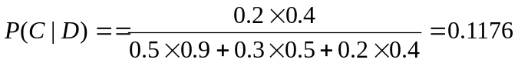

4. (12 points) Suppose random variable X and Y have joint pdf
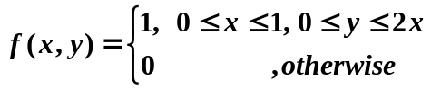
(a) Determine the marginal pdf of X and Y
(b) Calculate the expected value E(X+Y).
(c) Determine the conditional probability 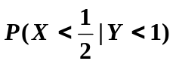
Solution: (a)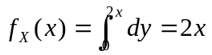,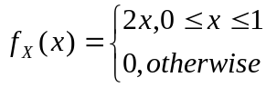,
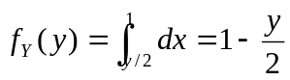, 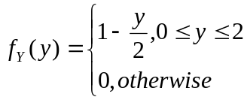

(b) E(X+Y)=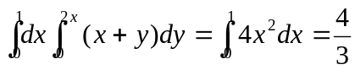
(c) 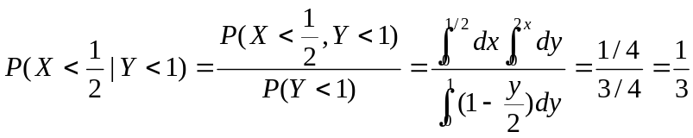

5. (12 points) If X, Y are have independent identical distribution random variables, and 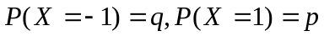, 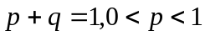. Set a random variable 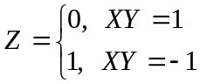,
a. determine the distrribution function of Z
b. determine the joint distribution function of (X,Z)
c. determine the value of  which supports X,Z independent
Solution: a. Z 0 1
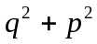 2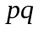

b.
Z  X | 0 | 1
-1 | 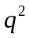
1 | 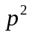
c. 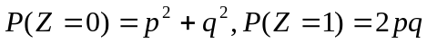, if X and Z independent ,then
, 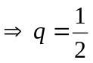,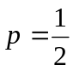
6. (12 points) If bearing diameter is normally distributed, what is the probability that the diameter of a randomly selected bearing is
a. within 1 SD (standard deviation) from its mean value?
b. farther than 2 SDs from its mean value?
c. within 3 SDs from its mean value?
Solution: (a)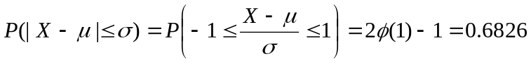
(b) 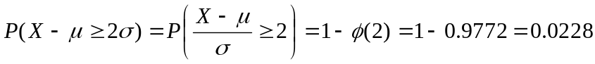
(c) 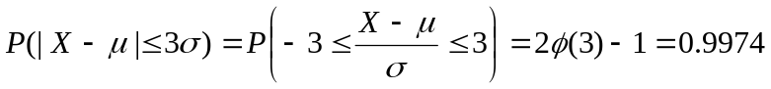
7. (10 points) Suppose X has geometric distribution with pmf 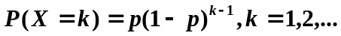
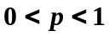, 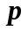 is a constant, determine E(X), V(X)
Soultion:
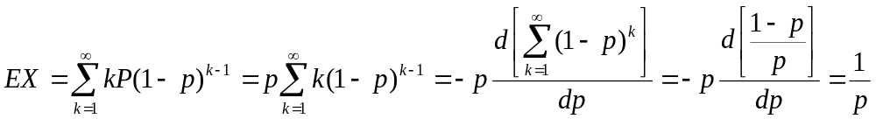
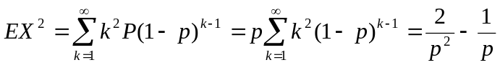
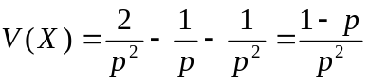

8. (12 points) The breaking strength of steel line produced by a factory has approximately normal distribution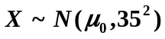(unit: kg/cm²). A sample of 9 is selected and the sample average strength is 20kg/cm² more than prior mean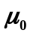. If the standard deviation is not changed, can we consider the breaking strength of this kind steel line have increased significantly?
(a) The significantly level 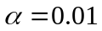
(b) If given 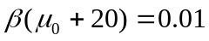(the type II error probability), then what value the sample size n at least must be.
Solution: (a) 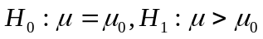
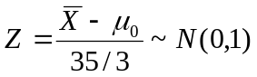
The reject range is 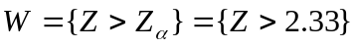
The sample value 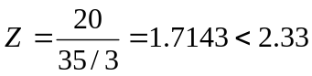, so, we can not consider the breaking strength of this kind steel line have increased significantly.
(b)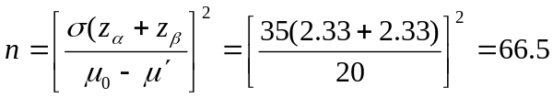, 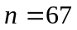

Table:
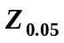 | 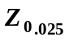 | 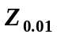 | 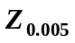
1.645 | 1.96 | 2.33 | 2.58

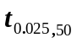 | 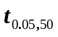 | 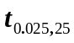 | 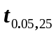
2.009 | 1.676 | 2.060 | 1.708

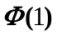 | 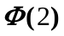 | 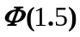 | 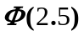
0.8413 | 0.9772 | 0.9332 | 0.9938

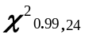 | 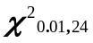 | 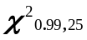 | 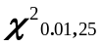 | 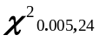 | 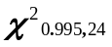 | 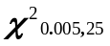 | 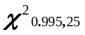
10.856 | 42.980 | 11.523 | 44.313 | 45.558 | 9.886 | 46.925 | 10.519

